Performance Analysis of Various Routing

Protocols in Wireless Network

**Aparna Joshi1, Rahul Desai2, Sachin Yadav3, Avinash Thakur4, Sunil Singh5, Abhishek6**

Assistant Prof, Department of Information Technology, Army Institute of Technology, Pune, India 1, 2

B.E Student, Department of Information Technology, Army Institute of Technology, Pune, India 3,4,5,6

**Abstract**: Mobile ad hoc network (MANET) is a continuously self configuring, infrastructure-less network of mobile devices connected without wires. Ad hoc is Latin and means “for this purpose”. Routing protocols like Destination-Sequenced Distance-Vector (DSDV), Ad hoc On-Demand Distance Vector Routing (AODV), and Dynamic Source Routing (DSR) and Ad hoc on Demand Multipath Distance Vector (AOMDV) have been implemented. In this paper, performance of two prominent on-demand reactive routing protocols for mobile ad hoc networks: DSR and AODV, along with the proactive DSDV protocol have been analyzed. The On-demand protocols, AODV and DSR perform better than the table-driven DSDV protocol. Although DSR and AODV share similar on-demand behaviour, the differences in the protocol mechanics can lead to significant performance differentials like Packet Delivery Ratio (PDR), throughput, control overhead, delay. The various performance differentials have been analyzed by varying network traffic, mobility, and network size.

Keywords: Source Routing, DSDV, DSR, AODV, PDR

1. Introduction

Wireless networking is a technology through which users can access information and services electronically, regardless of their geographic position. Wireless networking is a method by which buildings, telecommunications networks and enterprise (business) installations avoid the costly process of introducing cables into a building, or as a connection between various equipment locations thereby leading its popularity in the computing industry. Ad hoc network finds its application in vast areas.

Wireless networks can be configured in two ways i.e. Ad hoc or infrastructure mode. Wireless devices require WLAN cards and access points for communication. Wireless networks require equipments like Wireless Adapters and access points which are quite expensive. Maximum bandwidth provided by wireless network is about 11Mbps. The reliability of wireless networks is less as compared to wired network. WLAN is an example of wireless networks which uses Wired Equivalent Privacy (WEP) encryption to protect the data thereby making wireless networks as secure as wired networks.

Wireless networks have many applications such as it is used in areas of sensor networks for environmental monitoring, rescue operations in remote areas, Remote construction sites, and Personal area Networking, Emergency operations, Military environment, Civilian environments . The scopes of the ad hoc network are also associated with Dynamic topology changes, Bandwidth-constrained, Energy constrained operation, Limited physical security, Mobility-induced packet losses, Limited wireless transmission Wireless network has many applications such as it is used in areas of Sensor networks for environmental monitoring, Rescue operations range, Broadcast nature of the wireless medium, Hidden terminal problem, Packet losses due to transmission errors. Wireless networks can be classified into two types: Infrastructure and Infrastructure less (Ad hoc)*.* Infrastructure network consists of a network with fixed and wired gateways. Infrastructure mode requires a central access point that all devices connect to. All nodes of such networks behave as routers and take part in discovery and maintenance of routes to other nodes in the network. Ad hoc mode is also known as “peer-to-peer” mode. Ad-hoc networks don’t require a centralized access point. Instead, devices on the wireless network connect directly to each other. In table driven routing protocols, consistent and up-to-date routing information to all nodes is maintained at each node. In On-Demand routing protocols, the routes are created as on demand. The source sends packet to a destination by invoking the route discovery mechanisms in order to find the path to the destination.

1. OVERVIEW OF ADHOC ROUTING PROTOCOLS

*A. Destination-Sequenced Distance-Vector (DSDV)*

Destination Sequenced Distance Vector (DSDV) is a table driven pro-active protocol. This type of routing scheme is used in ad-hoc networks to solve the routing loop problem and hence it .In this routing scheme each node maintains a table which has the single entry of all the other nodes. This entry contains information about the node's IP address, hop count and the last known sequence number. In this scheme each node advertise to each neighbor its own routing information i.e. destination address, number of hops to destination and destination sequence number.

On each advertisement node increase its own destination sequence number and if the node is not reachable (timeout) increase sequence number of this node by one and set metric to infinity. The updated information is compared with the original routing table and the route with higher destination sequence number is selected, on equality of sequence number the route with better metric is selected. Thus this routing protocol guarantee loops freeness.

1. *Ad Hoc on-Demand Distance Vector Routing (AODV)*

The Ad hoc On Demand Distance Vector (AODV) is a routing protocol designed for ad hoc mobile networks (MANETs). AODV is intended for networks that may contain thousands of nodes. AODV comes under the category of reactive routing protocols (Reactive protocol establish a route on demand). Other routing protocol that uses reactive approach like AODV is DSR (Dynamic source routing) which is discussed in the paper. Advantages of using reactive approach are that it reduces the routing overhead. This paper consists of different graphs that analyses the performance of different routing protocols. Analysis is based on network size, as the network size keeps on increasing different routing protocols behave differently.

AODV is a reactive protocol (demand driven) that means route discovery mechanism will be initiated only if a route from source to destination is not known. AODV uses 3 types of control message to build and maintain a route from source to destination. These 3 messages are:

1) RREQ-This message is transmitted by the node that wants to create a route. Node will broadcast a route request to the entire node across the network. Nodes which will receive this request will update their routing table based on the information in packet and will set backward pointers to the source node.

RREQ message contains source node IP address, sequence number, most recent sequence number for the destination and the broadcast ID.

2) RREP – This message is send by the node that receives a RREQ message. RREP is send by the node if it is destination or it has a route to destination. Nodes in the network keep a track of the RREQ's source IP address and broadcast ID. If a node receives a RREQ which it has already processed, then it will discard the RREQ and will not forward it.

3) RERR - In AODV a route is active as long as there are data packets send periodically from the source to the destination. If the source stops sending data packets, the link will be timed out and will be removed from the intermediate node routing tables. If a link break occurs while the route is still active, the node upstream of the break send a route error (RERR) message to the source node to inform it about the unreachable destination. After the source node receives the RERR messages, if it still requires the route, it will reinitiate route discovery.

*C. Dynamic Source Routing (DSR)*

Dynamic Source Routing is a reactive routing protocol like AODV. However instead of relying on the routing table at each node it uses source routing. In the figure given below when A sends a data packet to D the entire route [A-B-C-D] will be included in the packet header.

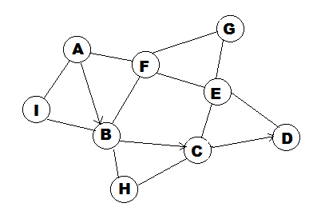

Fig: 1 DSR Source Routing

Intermediate nodes between A and D uses the source route embedded in the packet header to determine the next node to which the packet should be forwarded. In DSR different packets may have different routes even though they have the same route and destination. DSR also uses the same control messages that are used in AODV for route discovery and Route maintenance.

The main disadvantage of using DSR is that the packet header size will keep on growing with the route length because of source routing and hence become inefficient. Other disadvantage is the RREQ flooding

III Performance Parameters

The performance of the protocols depends on various parameters like PDR (packet delivery ratio), Throughput, Control overhead, Delay, Jitter etc. Here these parametershave beenconsidered to draw an analytical observation.

***Packet delivery Ratio*:**The ratio of the data packets successfullydelivered to the destination to those generated by the sources.

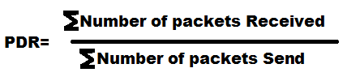

Performance is directly related with PDR, greater the value of PDR means the performance of protocol is good.

***Throughput*:** Throughput is the average of successful message delivered over a communication network. The average time of number of bits that can be transmitted by each node to the destination is calledper-node throughput. The sum of per-node throughput over all the nodes in a network is called the throughput of the network.

***Control overhead:-***

It is the time taken to transmit data on a wireless network.

Each packet requires extra bytes of format information that is stored in the packet header and combined with the assembly and disassembly of packets, decreases the overall transmission speed of the raw data.

IV RESULTS and Analysis

|  |  |  |  |
| --- | --- | --- | --- |
| **Measured** | **30 Nodes** | | |
| **AODV** | **DSR** | **DSDV** |
| **No. of packet Send** | 443 | 460 | 462 |
| **No. of packet receive** | 430 | 455 | 220 |
| **Packet delivery ratio** | 98.32 | 99.01 | 61.00 |
| **Control Overhead** | 390 | 70 | 423 |
| **Delay** | 0.417291 | 2.49973 | 0.760047 |
| **Jitter** | 0.0226 | 0.0264 | 0.2465 |
| **Number of packets dropped** | 13 | 5 | 242 |

*Table1: For 30 Nodes*

|  |  |  |  |
| --- | --- | --- | --- |
| **Measured** | **40 Nodes** | | |
| **AODV** | **DSR** | **DSDV** |
| **No. of packet Send** | 448 | 475 | 465 |
| **No. of packet receive** | 440 | 471 | 315 |
| **Packet delivery ratio** | 99.10 | 99.43 | 68.82 |
| **Control Overhead** | 280 | 115 | 551 |
| **Delay** | 4.16068 | 4.16068 | 1.72245 |
| **Jitter** | 0.0318 | 0.0318 | 0.2256 |
| **Number of packets dropped** | 4 | 4 | 150 |

*Table2: For 40 Nodes*

|  |  |  |  |
| --- | --- | --- | --- |
| **Measured** | **50 Nodes** | | |
| **AODV** | **DSR** | **DSDV** |
| **No. of packet Send** | 443 | 460 | 462 |
| **No. of packet receive** | 430 | 455 | 220 |
| **Packet delivery ratio** | 98.32 | 99.01 | 61.00 |
| **Control Overhead** | 390 | 70 | 423 |
| **Delay** | 0.417291 | 2.49973 | 0.760047 |
| **Jitter** | 0.0226 | 0.0264 | 0.2465 |
| **Number of packets dropped** | 13 | 5 | 242 |

*Table3: For 50 Nodes*

Comparison based on packet delivery ratio:-

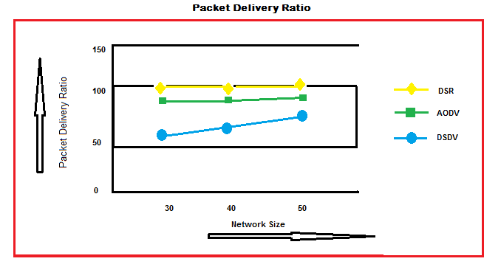

*Fig2 Packet Delivery Ratio for different protocols*

Based on the graph drawn using the simulation result given in table, packet delivery ratio for DSR and AODV are nearly the same but PDR for DSDV is poor in comparison to the other two.

Graph is drawn considering network size (Number of nodes) up to 50.

As we will keep on increasing the network size different protocols will behave differently.

Comparison based on Control Overhead:-

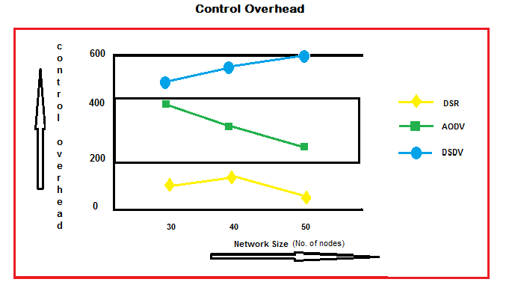

*Fig3 Control overhead for different protocols*

Figure 3 clearly depicts that the control overhead for DSDV protocol is higher than AODV and DSR. It is higher due to the fact that it keeps on updating routing table periodically.

Comparison based on End to End Delay:-

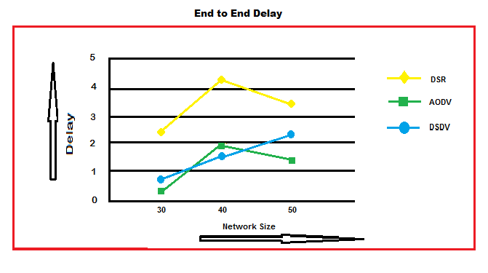

*Fig4 End to End delay*

V CONCLUSION

This paper illustrates the performance of three routing protocols i.e. AODV, DSR and DSDV. This paper also illustrates the performance of these routing protocols under different scenarios of varying the number of nodes. We have considered the performance metrics like Packet Delivery Ratio (PDR), Throughput, Control Overhead, Delay and we find that AODV performance is the best considering its ability to maintain connection by periodic exchange of data. Although for some parameters the performance of DSDV is better than the other two but due to the fact that DSDV is a table driven routing protocol it will become inefficient when we will increasing the network size beyond a certain limit, that is why for larger networks we consider AODV which is a on demand routing protocol. For PDR, DSR and AODV have almost the same performance but DSR performs a little better, for end-to-end delay AODV comes out to be the best. Considering the throughput, AODV and DSR perform better than the DSDV even when the network has the large number of nodes. Overall our simulation shows that AODV performs better than DSDV and DSR. Our future plan is the security issues in AODV.

REFERENCES

[1] P.K. Maurya, Gaurav Sharma,” An overview of AODV Routing Protocol” Interational Journal of Modern Engineering Research, 2012.

[2] Neha Singh, Vinita Mathur,”Network Simulator NS2-2.35”, International Journal of Advanced Research in Computer Science and Software Engineering, May-2012.

[3] Md. Anisur Rahman, Alex Talevski,”Performance Measurement of Various Routing Protocols in Adhoc Network”, International Multiconference of Engineers and Computer Scientists,March-2009.

[4] Samyak Shah, Amit Khandre, “Performance Evaluation of Adhoc Routing Protocols using NS2 Simulation”.

[6] Tao Lin, Scott F.Midkiff and Jahng S.Park ,”A framework for Wireless Ad hoc Routing Protcols”, IEEE 2003.

[7] Zuraida Binti Abdullah Hani and Mohd. Dani Bin Baba, “Designing Routing protocols for Mobile Ad hoc networks”,IEEE

2003

[8] <http://www.isi.edu/nsnam/ns/tutorial>

[9] <http://www.youtube.com/watch?v=zpL-ykyhtBQ>

[10] Network Simulator - 2 (NS-2) <http://mohit.ueuo.com/NS-2.html>

[11] Eitan Altman and Tamia Jimenez, “NS for Beginners",[http://wwwsop.inria.fr/maestro/personnel/Eitan.Altman/COURS-NS/n3.pdf, Jan-2002](http://wwwsop.inria.fr/maestro/personnel/Eitan.Altman/COURS-NS/n3.pdf,%20Jan-2002).

[12] Wikipedia, “The free encyclopedia-, Mobile ad-hoc Network”, [http://en.wikipedia.org/wiki/Mobile_ad-hoc_ network, Oct-2004](http://en.wikipedia.org/wiki/Mobile_ad-hoc_%20network,%20Oct-2004).